Supporting Information

Multilayered and heterogeneous hydrogel construct printing system with crosslinking aerosol

Gihyun Lee1, Soo Jee Kim1, Honggu Chun2 and Je-Kyun Park1,3,4

1 Department of Bio and Brain Engineering, Korea Advanced Institute of Science and Technology (KAIST), 291 Daehak-ro, Yuseong-gu, Daejeon 34141, Republic of Korea

2 Department of Biomedical Engineering, Korea University, 145 Anam-ro, Seongbuk-gu, Seoul 02841, Republic of Korea

3 KAIST Institute for Health Science and Technology, 291 Daehak-ro, Yuseong-gu, Daejeon 34141, Republic of Korea.

4 Author to whom any correspondence should be addressed.

E-mail: jekyun@kaist.ac.kr

C:\Users\NBL23-GLee\AppData\Local\Microsoft\Windows\INetCache\Content.Word\FigS1.tif

**Figure S1.** Multibarrel nozzle preparation procedure, including thermal pulling, mechanical grinding, sterile cleaning, and assembly of the multibarrel nozzle with tubes.

C:\Users\NBL23-GLee\AppData\Local\Microsoft\Windows\INetCache\Content.Word\FigS2.tif

**Figure S2.** Specification of a crosslinking agent nebulizer. (A) A microscopic image of the sprayed aerosol and (B) size distribution plot of the aerosol. Average size = 6.95 ± 2.29 µm. (C) Control of the aerosol flow rate by adjusting the electrical resistances.

D:\GihyunLee\11_Research\2_Reports\Journal Flow\2021_1st_Biofab_Heterogeneous construct printing system\3_Review\Figures\Final version\GLEE_BF2021_FigS3.tif

**Figure S3.** The effect of the aerosol-based crosslinking technique for printing multilayered hydrogel constructs. (A) The effect of the crosslinking aerosol in the continuous printing of the 6- and 15-layerd alginate constructs. (B) The alginate constructs with the 1, 6, and 15 layers printed under the crosslinking aerosol.

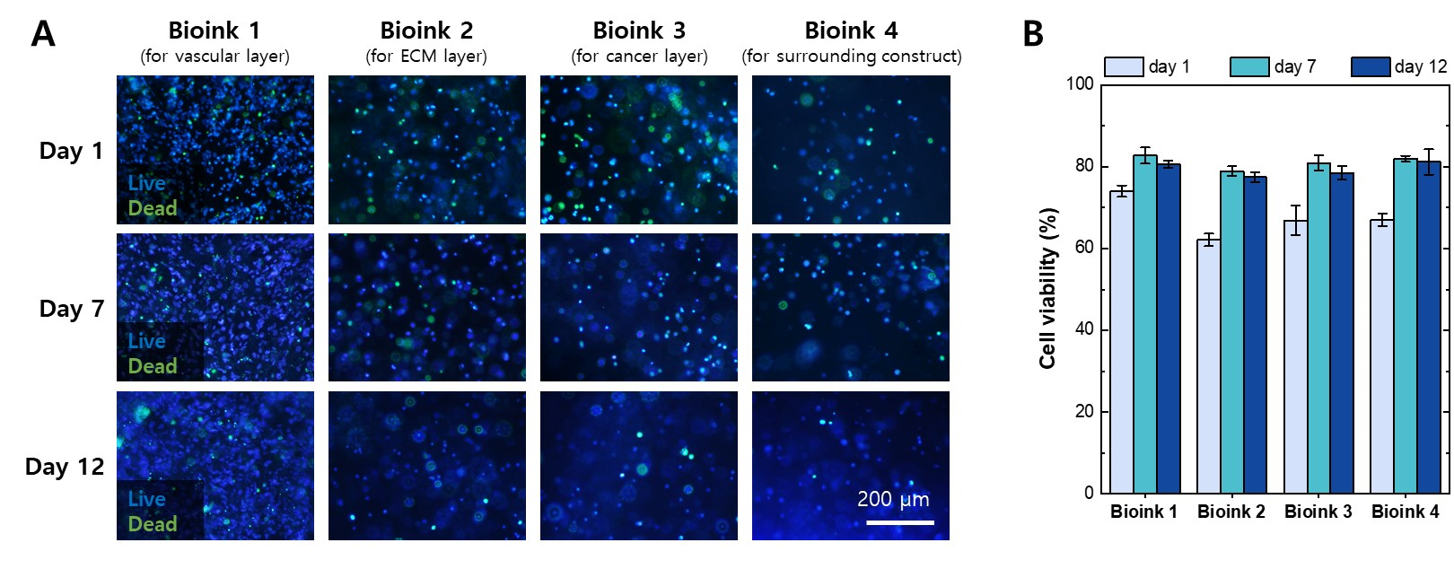

**Figure S4.** Live/dead assay after printing each bioink under specific printing conditions. (A) Fluorescent images of live (blue) and dead (green) cells after printing each bioink. (B) Viability of the cells cultured after 1, 7, and 12 days. Each bioink was made differently depending on the structure to be printed. Bioink 1 for printing a vascular layer had 5 × 106 HUVECs/mL and 1 × 106 LFs/mL in 0.5% alginate-RGD–2.5 mg/mL fibrinogen. The bioink 1 was printed under a pressure of 25 mbar. Bioink 2 for printing an extracellular matrix layer had 2 × 106 LFs/mL in 1% alginate-RGD–1.5 mg/mL collagen type I. The bioink 2 was printed under a pressure of 350 mbar. Bioink 3 for printing a cancer layer had 3 × 106 GFP MDA-MB-231 cells/mL in 1% alginate-RGD–1.5 mg/mL collagen type I. The bioink 3 was printed under a pressure of 350 mbar. Bioink 4 for printing a supporting construct consisted of 2 × 106 LFs/mL in 8% alginate. The bioink 4 was printed under a pressure of 2600 mbar.

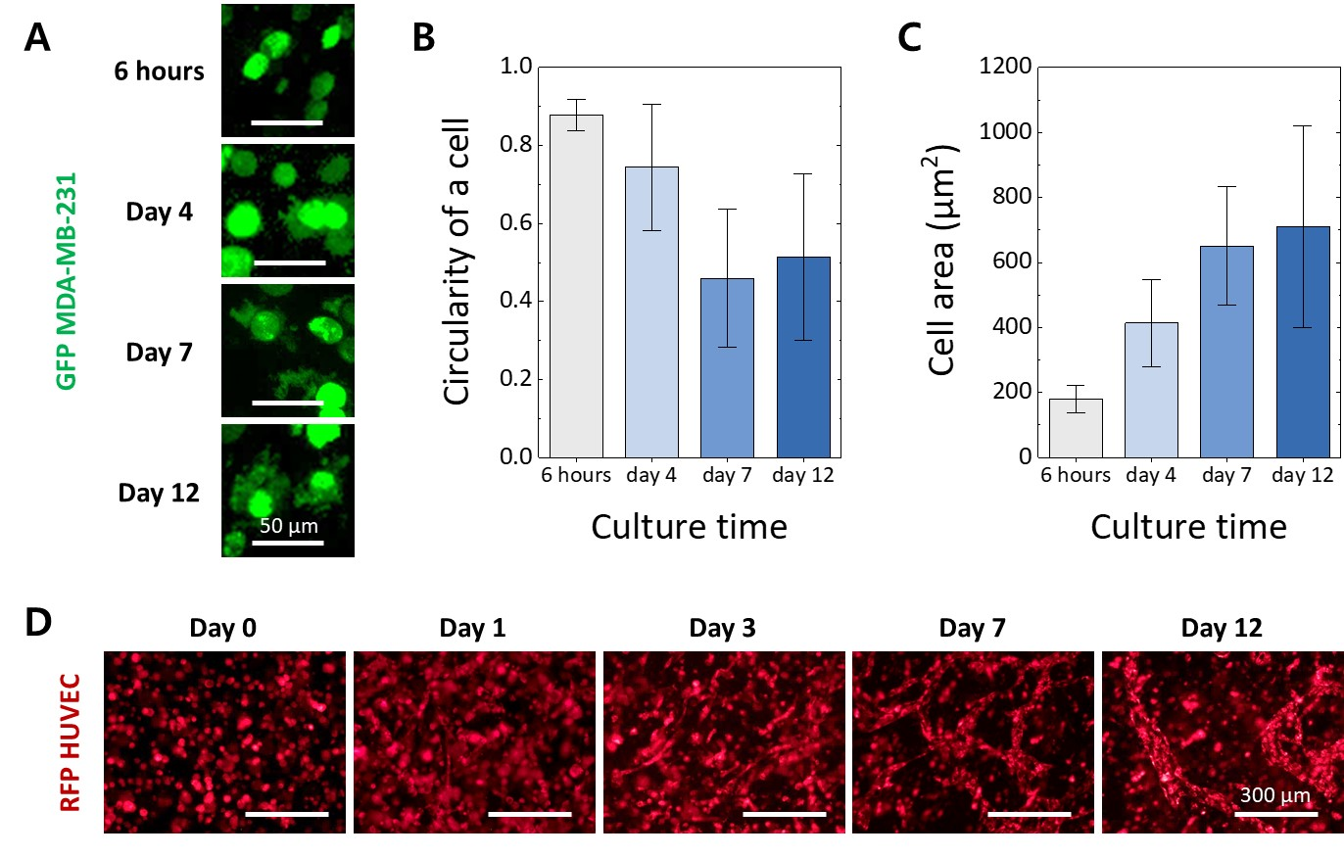

**Figure S5.** Cellular morphology changes of GFP MDA-MB-231 and RFP HUVEC cultured in each layer of the printed construct.(A) The morphology change of GFP MDA-MB-231 cultured for 12 days. The quantitative analysis for the morphological change of the single GFP MDA-MB-231 cell using representative parameters, (B) circularity and (C) cell area. The round shape of the breast cancer cells after 6 h of culture was changed more spread and irregular shapes over time. The cell shape of GFP MDA-MB-231 cultured in a printed cancer microenvironment was analyzed using the ImageJ software. (D) The morphology change and vascular network formation of the RFP HUVECs cultured for 12 days.

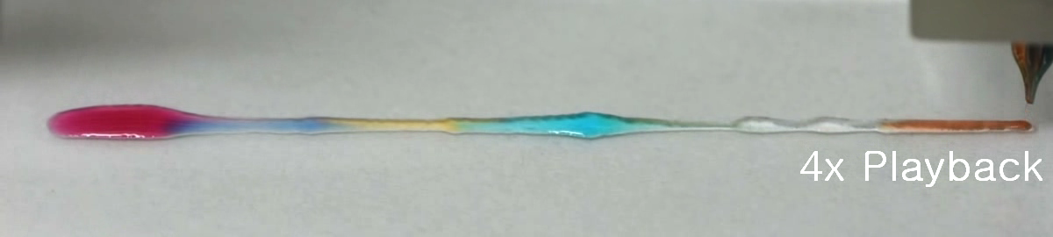

**Captured Image from Video 1.** A seven-color alginate line printed in the pneumatic pressure profile applied to each barrel of the multibarrel nozzle.